Using Pacing to Reach Your Goals

When people first injure themselves, pain acts like a signal that harm has been caused to the body. The natural and healthy reaction is to stop whatever is causing the pain (for example, walking on a sprained ankle, lifting with a strained back). In this case, harm is being done to the body and the body’s warning system (pain) is working properly. However with persistent pain, healing has usually occurred but pain remains. Thus, the body’s warning system is no longer working properly. In other words, the pain no longer indicates harm is being done to the body. Therefore, stopping the activity that causes the pain is not necessarily helpful.

People with chronic pain are often very inactive during episodes of severe pain, laying or sitting for extended periods. Through the course of the natural pain cycle, they eventually experience some pain relief When the severe pain starts to go away, they often try and make up for all the things they were unable to do during the severe pain episode (i.e., they over-do it). Since their body has lost strength and endurance during these extended periods of inactivity, even normal activities can result in increased pain. As a result, a cycle of ‘under-doing’ it followed by ‘over-doing’ it is created. Pacing activity helps patients to break this cycle.

Starting a gentle exercise program may greatly reduce pain, and strengthen your body against worsening pain. Even though it is difficult, focusing on slowly getting back to activities that hurt but are not harmful can make a huge difference in your daily life. Perhaps you might try a walking program, yoga, chair exercises, water aerobics, or another activity that your primary care provider suggests. Pacing puts you in charge of your limits, not your pain.

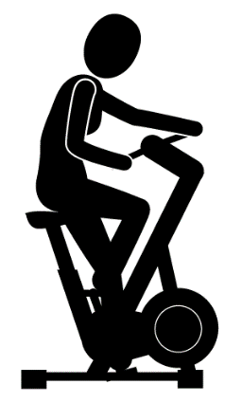

Practice Pacing and Noticing

To help you practice pacing over the next 2 months, try noticing when you are being under-active or over-active. Ask yourself:
- When was I especially over-active? ________________________________________________________________________________________________________________________________________________________________________
- When was I especially under-active? ________________________________________________________________________________________________________________________________________________________________________
- Am I having worry thoughts that I will hurt myself if I do a little bit more?
___________________________________________________________________________________
- Are these thoughts accurate? Or is this a false pain signal? Would it be okay to experiment with a little more movement? ____________________________________________________________________________________________________________________________________________________________________________________________________________________________________________________________
- What is an activity I need to pace better?
________________________________________________________________________________________________________________________________________________________________________

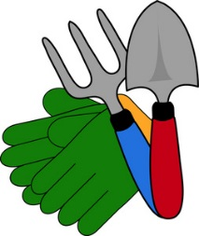
Note: This patient information was drawn from a variety of evidence-based sources. This handout is part of a research study and is being used in an enhanced treatment condition (PI: Kanzler, KE).

